**Interactive Multimedia Programming**

**2. Assignment set Responsive Web Design and stuff**

**1. RWD:**

Responsive web design (RWD) is one of the trendiest technology buzz words in web development. The terms was originally introduced in Ethan Marcotte’s A List Apart article in 2010. http://alistapart.com/article/responsive-web-design .

1. Read the article carefully

2. Review also all the examples in the article. Review the code and see how the responsiveness develops between different versions.

Answer to following questions:

• What is the purpose of the RWD? Why it is used? How things are done before RWD? What is the difference?

• How css media queries can help you building responsive web sites?

• Why to use em (font) based sizing for example margins?

• Article is already 7 years old, do we have any new technology which can be used to achieve same type of UI responsiveness as described in the article. Buzz words: (CSS Grid, Flexbox)

**2. RWD Examples:**

See few RWD examples. Test how different screen sizes works in desktop browser. Test also sites on mobiles.

• https://www.bostonglobe.com/ (Ethan Marcotte works here)

• This site lists good examples of sites which uses media queries, test few from here: http://mediaqueri.es/ Take screenshots of the sites on different devices and screen sizes.

**On PC:**

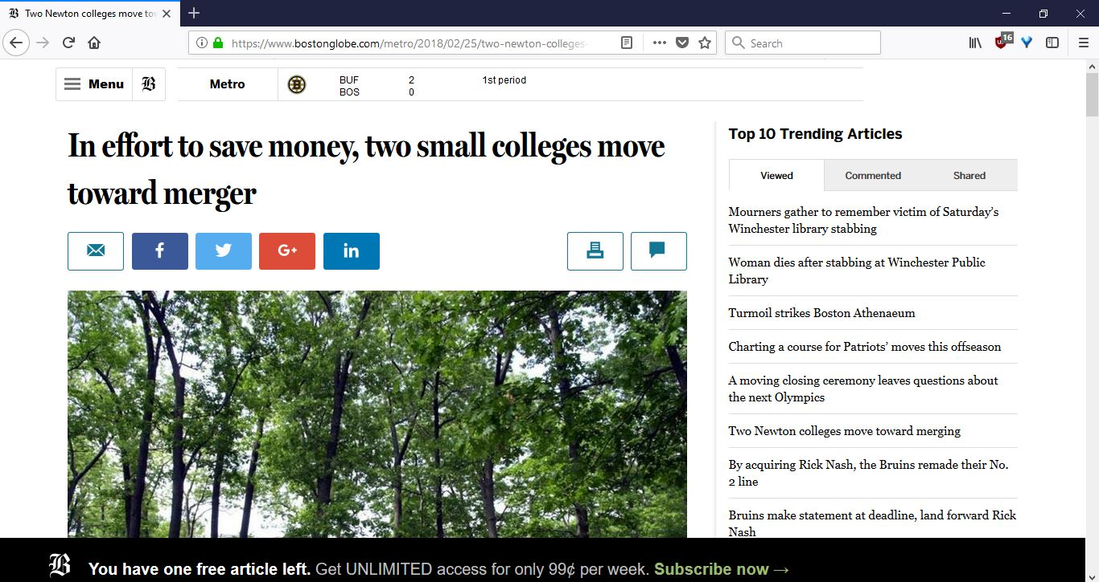

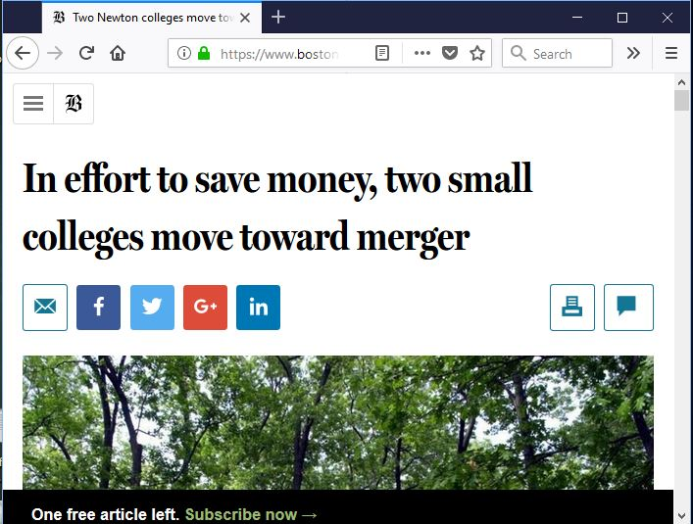

**On Mobile:**

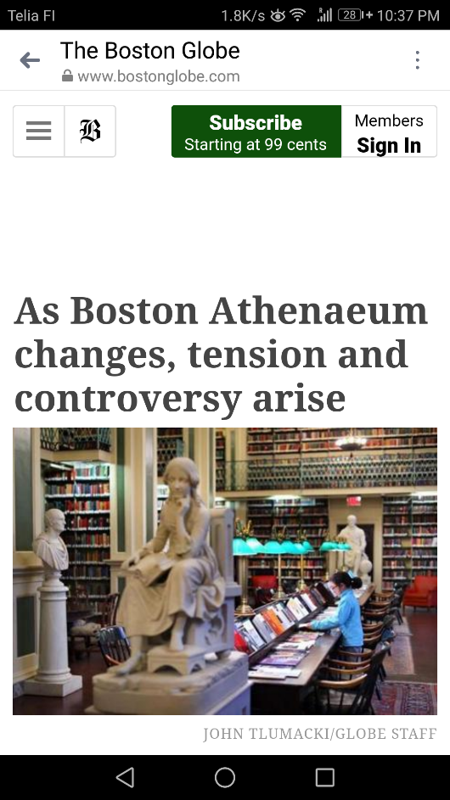 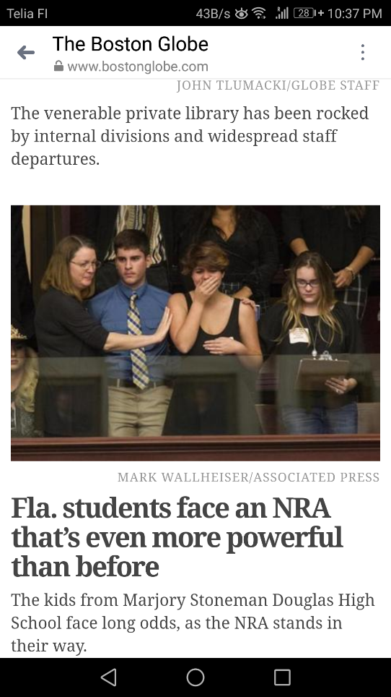

**3. RWD in practice**

Create a simple responsive web page where nothing is deﬁned as pixels. Use CSS-reset (http://cssreset.com/what-is-a-css-reset/), and remember to follow coding conventions. Styles must be stored in separate .css ﬁles.

Here are few screenshots you should follow:

If you have problems on mobile (in scaling), read this article: <https://developer.mozilla.org/en/docs/Mozilla/Mobile/Viewport_meta_tag>

After you have done the basic layout, how could you prevent user zooming the site on mobile?

**Answer:**

**<meta name='viewport' content='width=device-width, initial-scale=1.0, maximum-scale=1.0, user-scalable=0'>**

If you wish, you could also use Android SDK emulator to see the rendering in mobile.

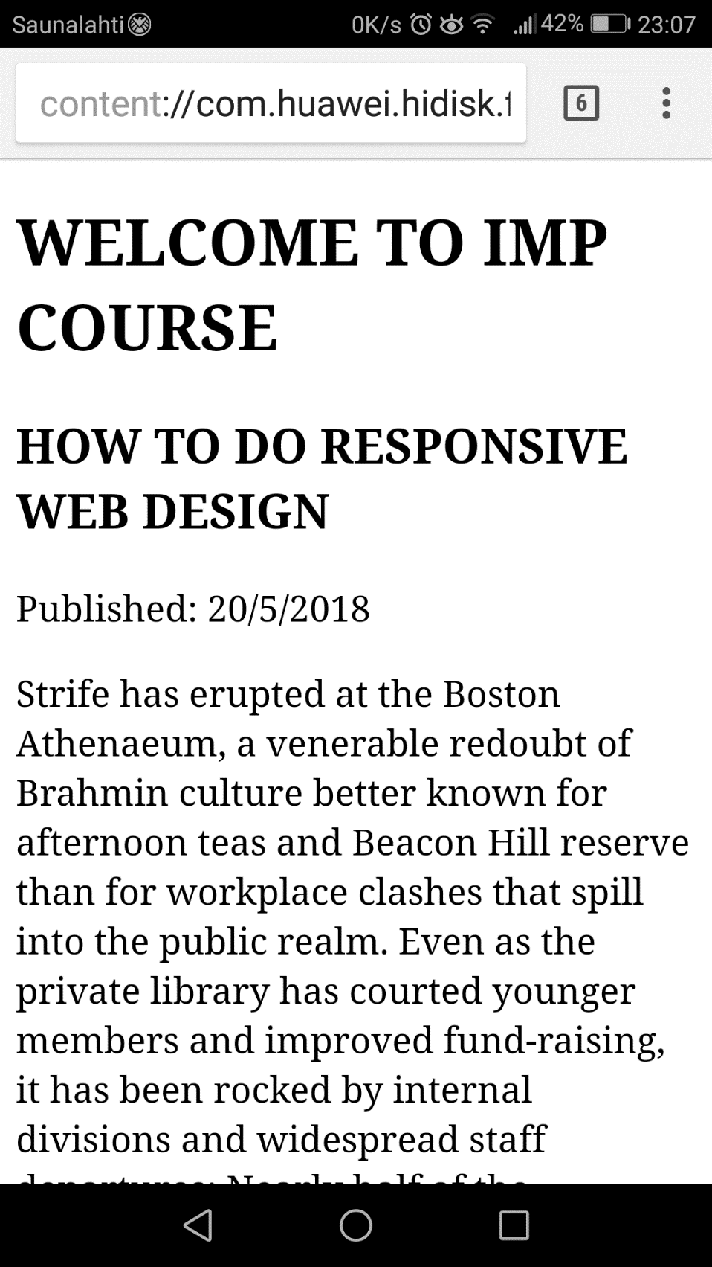

**4. Adding stuff**

1. **Create a copy of previous task.**
2. **Add a menu to it. Menu should be on the left side of the screen on wide screen, but on the top on mobile portrait screen. See the ﬁgures below:**
3. **Same page in desktop browser and in mobile browser No horizontal scroll! No media queries used!**
4. **HTML5 speciﬁcation introduces new semantic elements. One of them is a <ﬁgure> element. Can you say why you should use it in addition to standard <img> elements?**

**Answer:**

The tag provides a **container** for content that is equivalent to a figure or diagram in a book. **It can be used to group a caption with one or more images, a block of code or other content**.

1. **Add few ﬁgure elements to previous assignment. Images should scale keeping their aspect ratio based on the width of the document. See examples:**

**5. Responsive person list**

Create a copy of last week’s person list project. Make it responsive!